CO3- AT3- Tree Traversal Challenges
Write the traversal sequences for following trees
NAME: S. HARINIKA
REG NO: 192521444
Question No :1
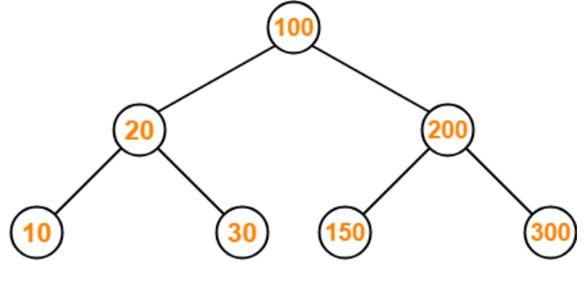

Tree:
- Root = 100
- Left subtree = 20 → 10, 30
- Right subtree = 200 → 150, 300
Preorder (Root → Left → Right):
100, 20, 10, 30, 200, 150, 300
Inorder (Left → Root → Right):
10, 20, 30, 100, 150, 200, 300
Postorder (Left → Right → Root):
10, 30, 20, 150, 300, 200, 100

Question No : 2
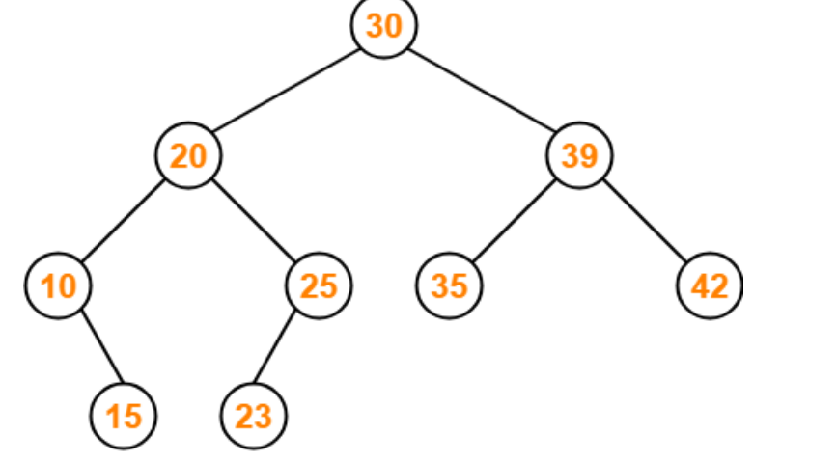
Tree:
- Root = 30
- Left = 20 → 10, 25
- 10 → 15
- 25 → 23
- Right = 39 → 35, 42
Preorder:
30, 20, 10, 15, 25, 23, 39, 35, 42
Inorder:
10, 15, 20, 23, 25, 30, 35, 39, 42
Postorder:
15, 10, 23, 25, 20, 35, 42, 39, 30

Question No : 3
Assume the digits 7, 5, 1, 8, 3, 6, 0, 9, 4, 2 are added in that sequence into a binary search tree that is initially empty. The binary search tree follows the standard natural number ordering. What is the resulting tree's traversal sequence?
Preorder:
7, 5, 1, 0, 3, 2, 4, 6, 8, 9
Inorder:
0, 1, 2, 3, 4, 5, 6, 7, 8, 9
Postorder:
0, 2, 4, 3, 1, 6, 5, 9, 8, 7
7
/ \
5 8
/ \ \
1 6 9
/ \
0 3
/ \
2 4

Question No : 5
1
/ \
2 3
/ \ \
4 5 6
/
7
ANS:
1
/ \
2 3
/ \ \
4 5 6
/
7
Preorder:
1, 2, 4, 7, 5, 3, 6
Inorder:
7, 4, 2, 5, 1, 3, 6
Postorder:
7, 4, 5, 2, 6, 3, 1

Question No 6
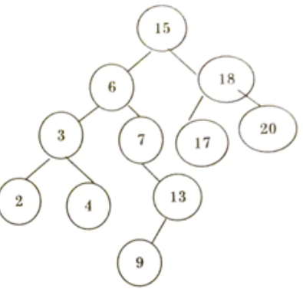
15
/ \
6 18
/ \ / \
3 7 17 20
/ \ \
2 4 13
/
9
Preorder:
15, 6, 3, 2, 4, 7, 13, 9, 18, 17, 20
Inorder:
2, 3, 4, 6, 7, 9, 13, 15, 17, 18, 20
Postorder:
2, 4, 3, 9, 13, 7, 6, 17, 20, 18, 15

Question No 7
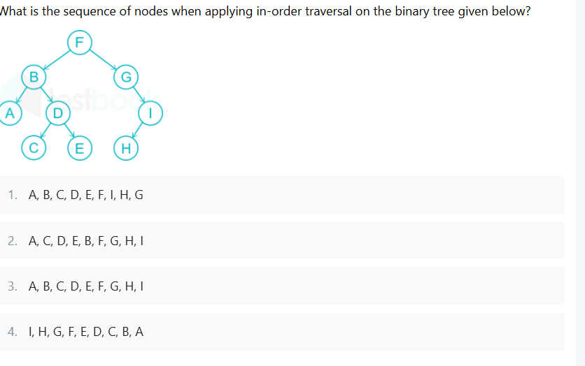
OPTION:3
Question No 8
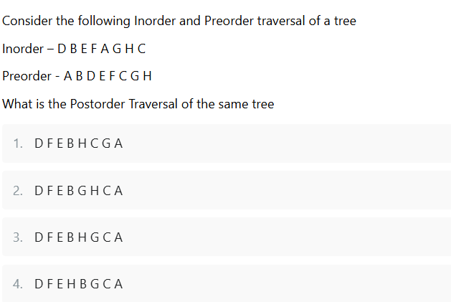
OPTION: 1
Question No 9 : Find Inorder, Preorder and Postorder
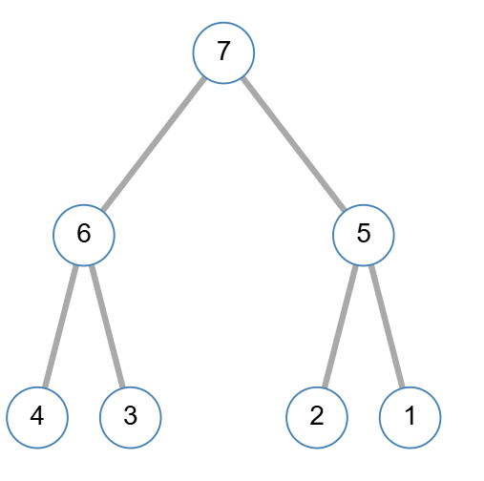
7
/ \
6 5
/ \ / \
4 3 2 1
Inorder
4, 6, 3, 7, 2, 5, 1
Preorder
7, 6, 4, 3, 5, 2, 1
Postorder
4, 3, 6, 2, 1, 5, 7

Question No 10
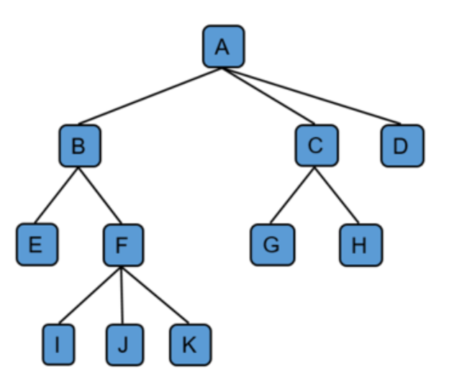
A
/ | \
B C D
/ \ / \
E F G H
/|\
I J K
Preorder
A, B, E, F, I, J, K, C, G, H, D
Postorder
E, I, J, K, F, B, G, H, C, D, A
Level Order
A, B, C, D, E, F, G, H, I, J, K

